
No. CSC/T.120/ MNP/ 10-11/23 DT AT CNI 6 THE 20/01/2011

To
All Heads of SSAs in Tamilnadu Circle

Kind attention – AGMs (CSC)

Sub: Guidelines on Mobile Number Portability pertaining to franchisees.
--------------
In continuation of the earlier guidelines regarding Mobile Number Portability, it has now been decided that the franchisees also can collect the MNP applications for port-in customers. In this regard, AGMs (CSC) may follow the following instructions:
- Franchisees may submit the excel sheet in triplicate along with the field CAF as usual, with annexure for MNP Port-in applications.
- FRC amount pertaining to the plan of the customers’ choice is to be collected and the same is to be remitted along with the excel sheet to the Customer service Centre along with the application forms. The CSCs will give one copy of the same to the franchisee as acknowledgement, affixing date and time of submission, and one copy to the Accounts Officer (Sales) of the SSA concerned along with the amount and get a receipt for remittance of cash. The third copy may be kept by the CSC in charge for record.
- At the CSC, for the post-paid customers, mapping of the new SIM along with the plan required by the customer is to be created within Kenan FX . and for prepaid customers, the above mapping is to be carried out on SancharSoft immediately. The created SIM will be kept in a separate cover, mentioning the name and address of the customer, SIM number, mobile number, serial number of the excel sheet, etc., and made over to the franchisee within 48 hours of the receipt of excel sheet.
- A consolidated report may be given to the AGM (Sales-CM) of the SSA for further processing of the case.

Sd/..
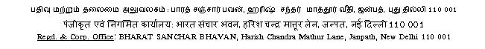
[G. SWAMINATHAN]
ASST. GENERAL MANAGER [CSC]

